Spacing Issue
As discussed, please remove the unnecessary gap between section and maintain consistent spacing throughout the website.

As discussed fix the image issue throughout the website also give me size of the image so that we can change the images of website



favicon missing

Check the sentence case throughout the website.

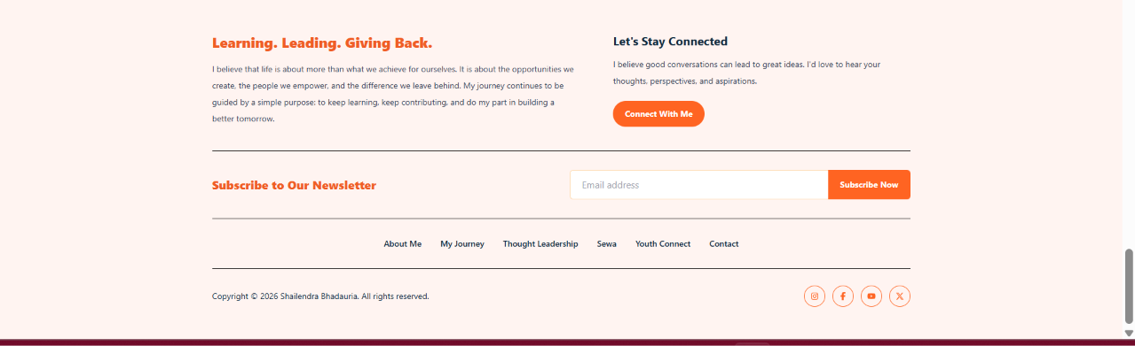
Footer Updates (All Pages)
Sequence for footer across all pages:
- Subscribe to Our Newsletter
- Learning. Leading. Giving Back.
- Copyright © 2026 Shailendra Bhadauria. All rights reserved.
Ensure the footer is consistent across all pages.
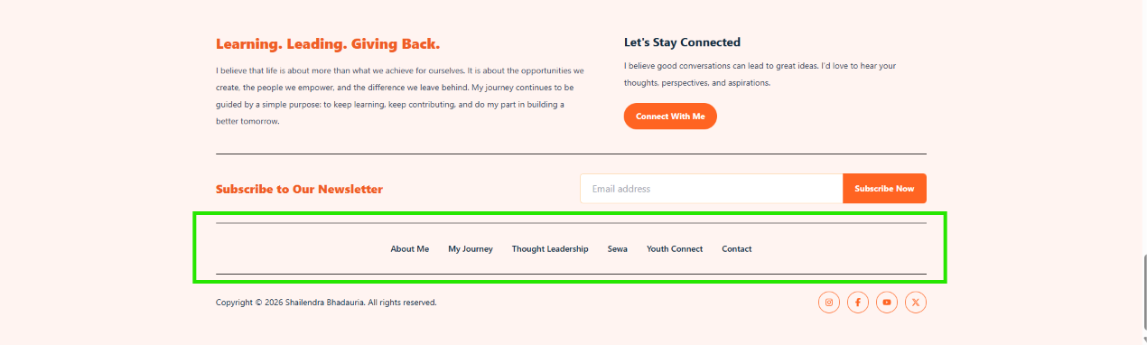

Remove this from all page footer

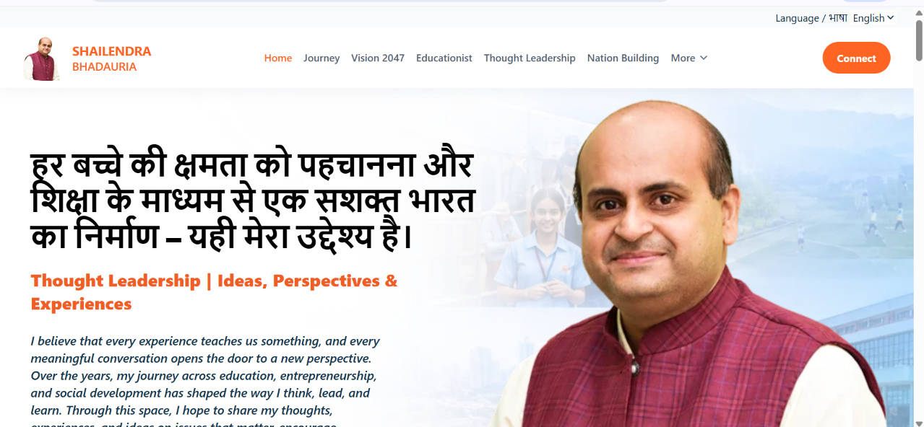

शिक्षा, संस्कार और सशक्त भविष्य का संकल्प।

I believe every experience offers a lesson, and every meaningful conversation brings a fresh perspective. Over the years, my journey in education, entrepreneurship, and leadership has shaped my vision. Through this space, I aim to share insights, experiences, and ideas on education, innovation, youth empowerment, and issues shaping India's future.

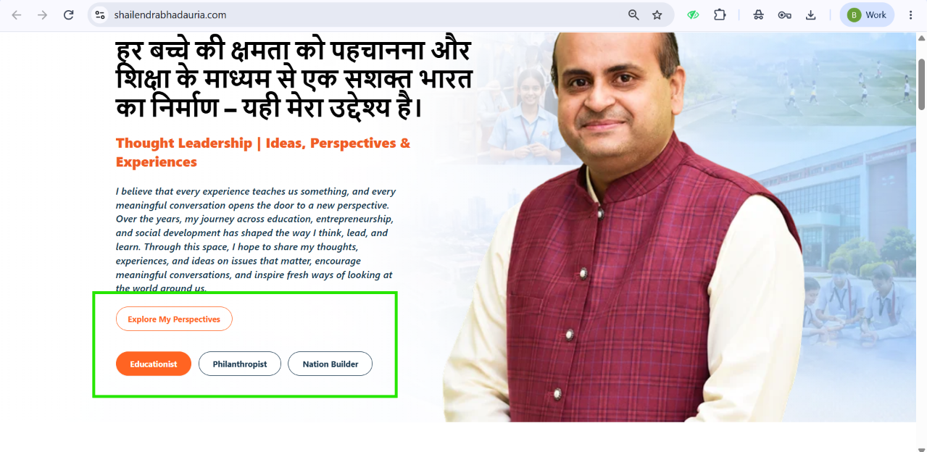

Explore my perspectives | Educ
ationist | Nation builder

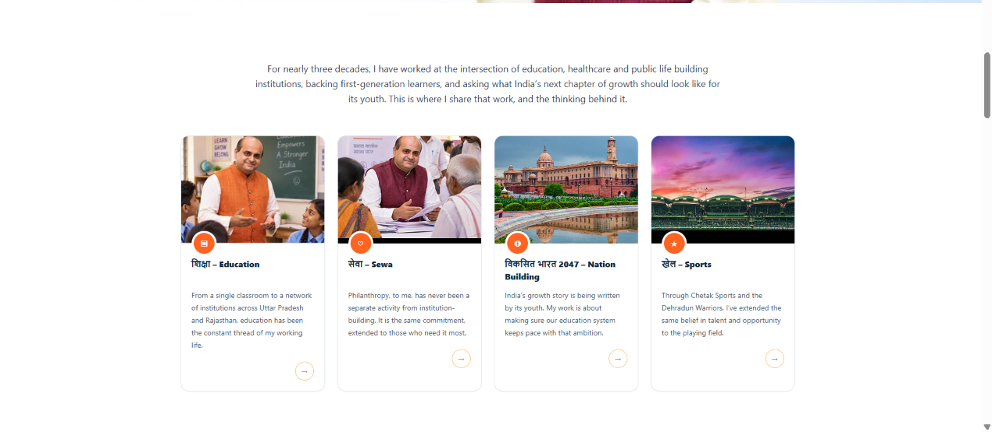

Missing Headings



Blogs & Articles Section (For all pages)

The Blogs & Articles section is currently not displaying. Please fix this issue.

Update the section order as follows:

Blogs & Articles

FAQ

Contact Form

Footer

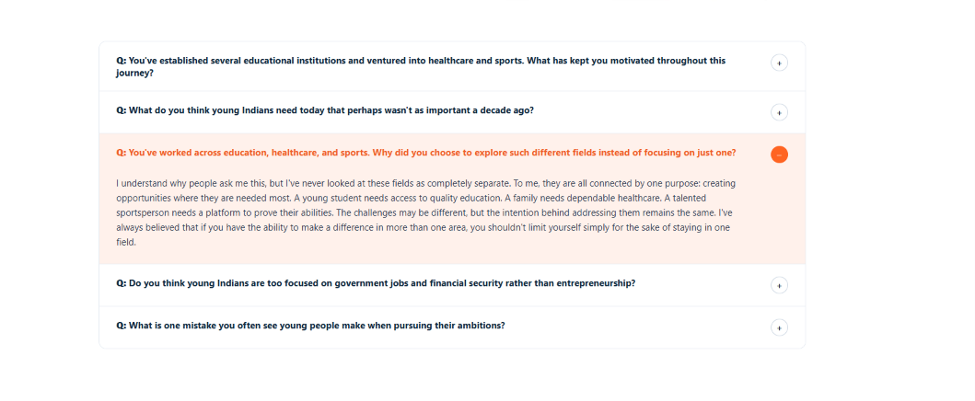

Heading is missing

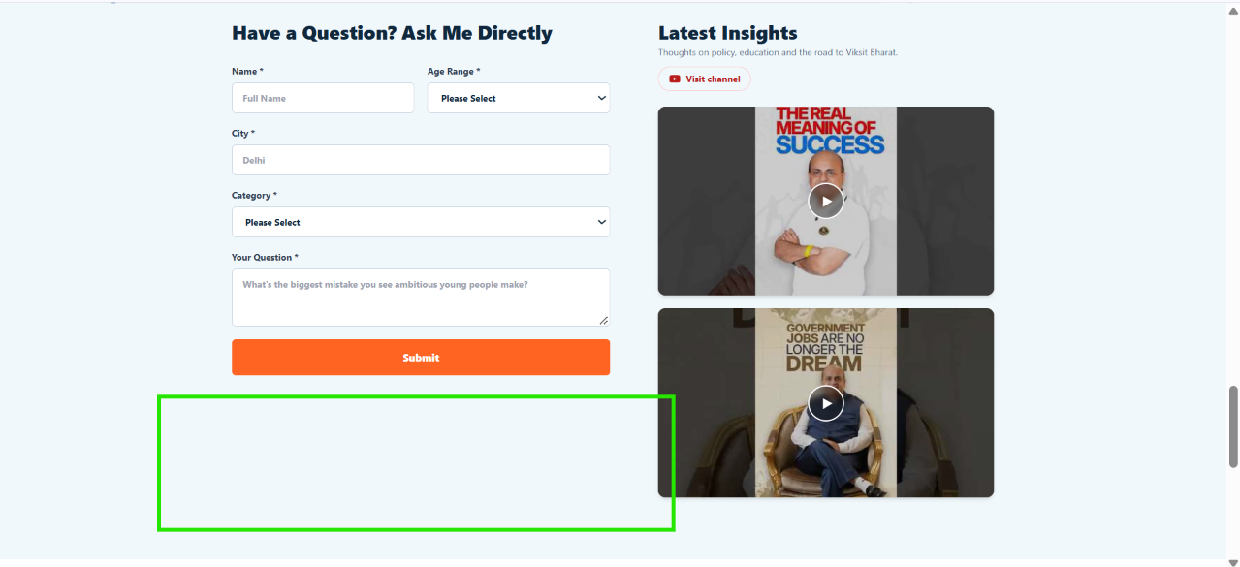

As discussed remove this gap

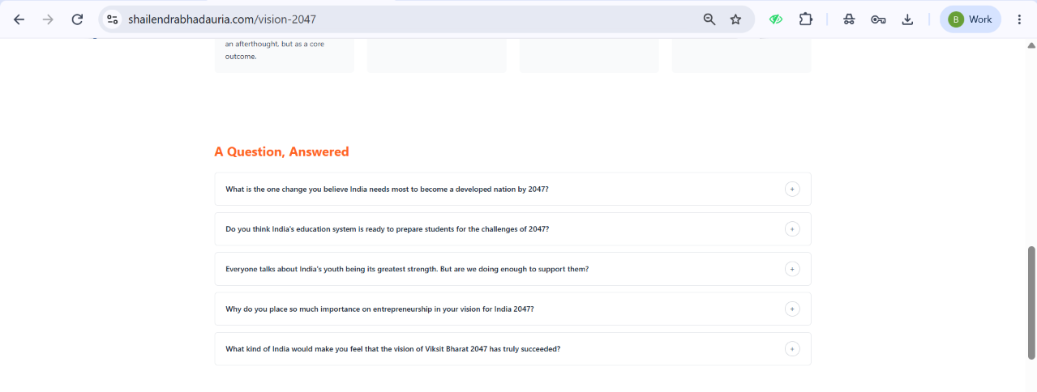

Content not updated



No related reading this section was for blog & article

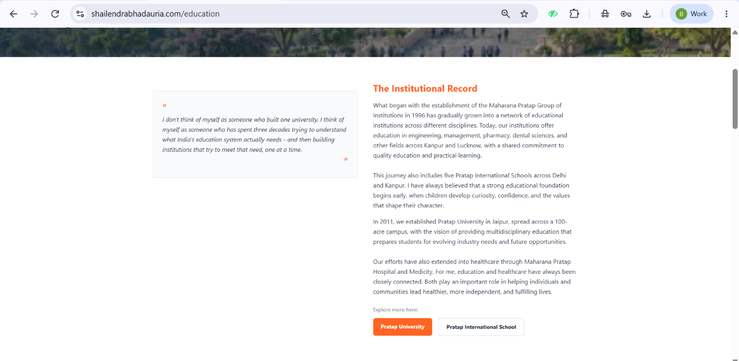

Design this section well

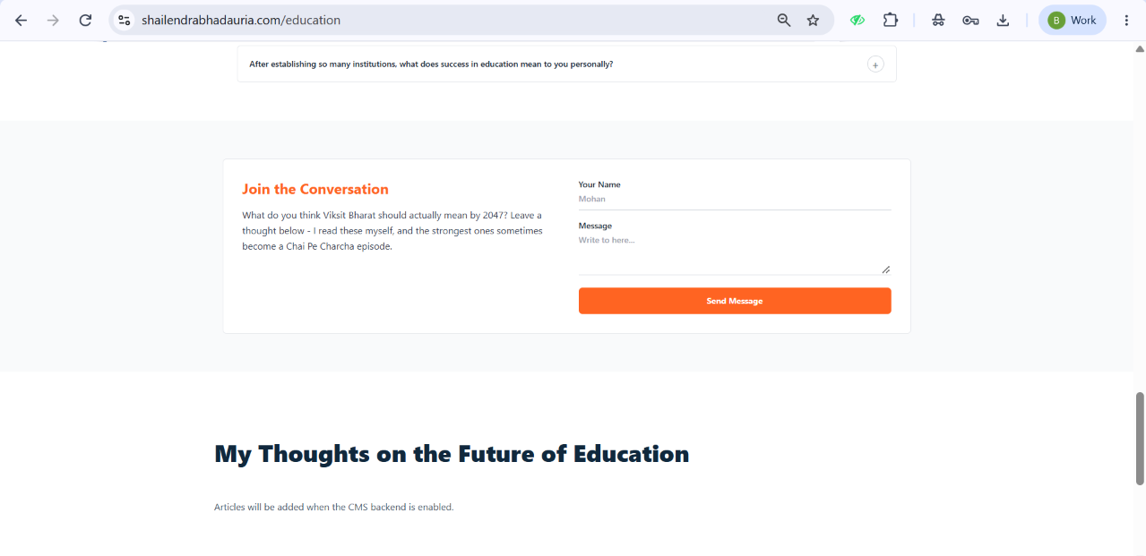

Same sequence issue

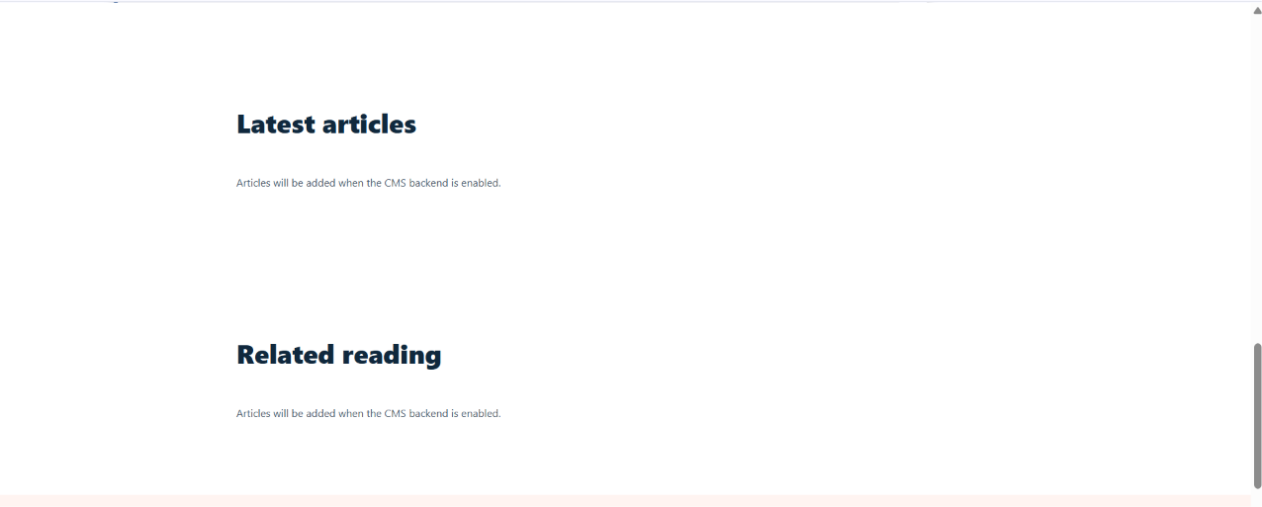

No related reading this section was for blog & article
Same sequence issue

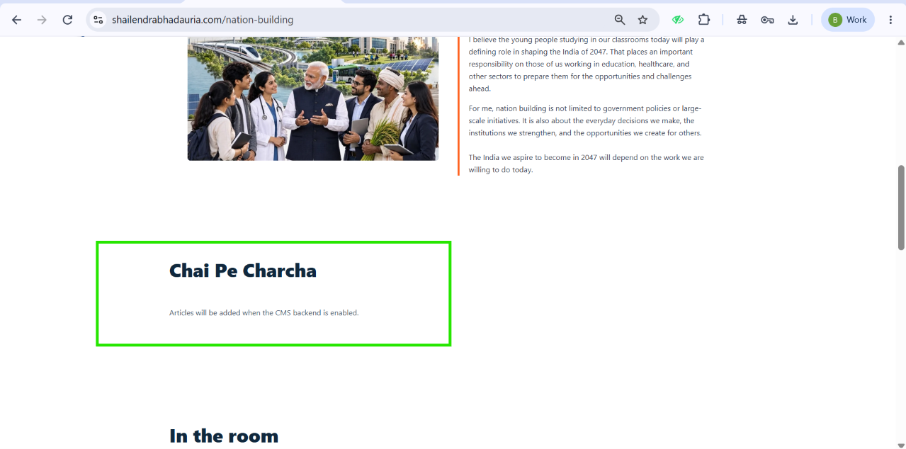

Heading will be Coffee Pe Charcha and as discussed we are doing a series on youtube those video will come here

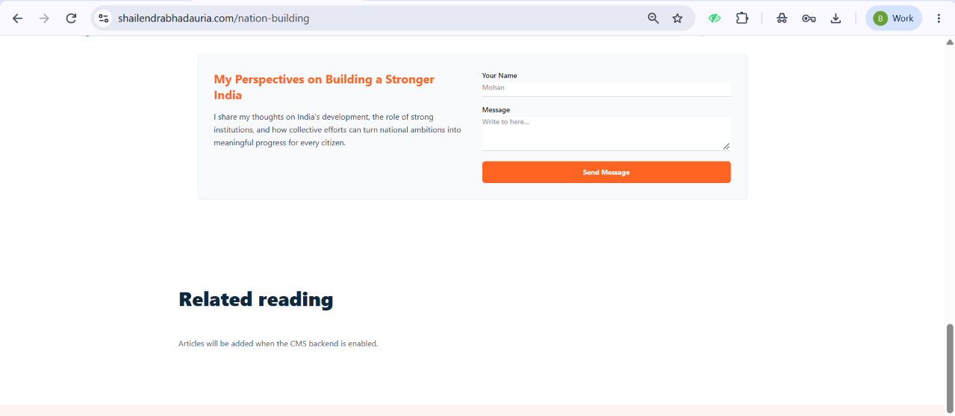

Remove related reading

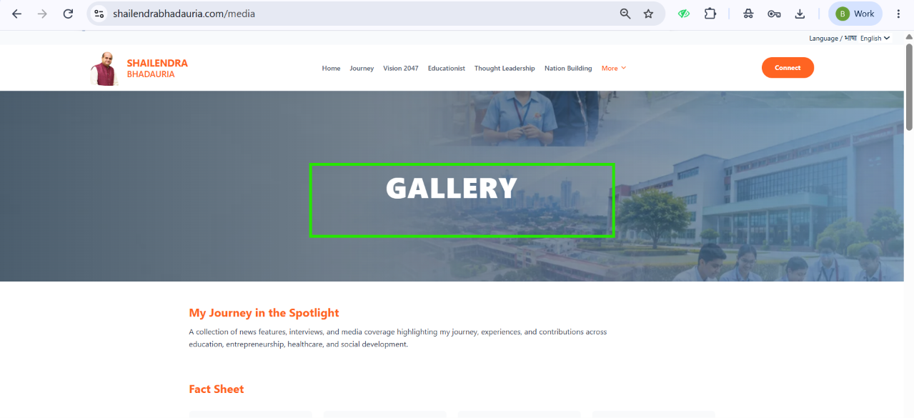

Media Centre

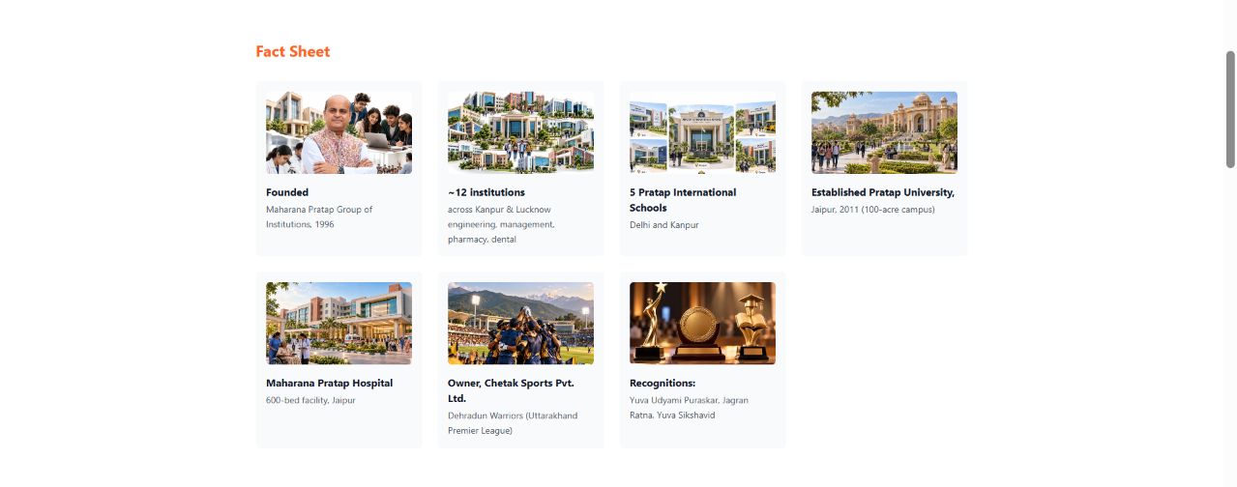

As discussed,
Section 1: In the Digital Spotlight
Online news coverage displayed in a horizontal scroller. Clicking an article redirects users to the original news link.
Section 2: In the Print Spotlight
Newspaper clippings and print media coverage displayed in a horizontal image scroller. Clicking an image opens an enlarged view.

https://streesports.com/media-centre

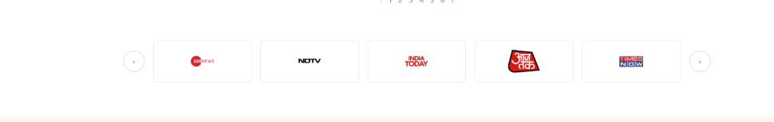

This will come after banner

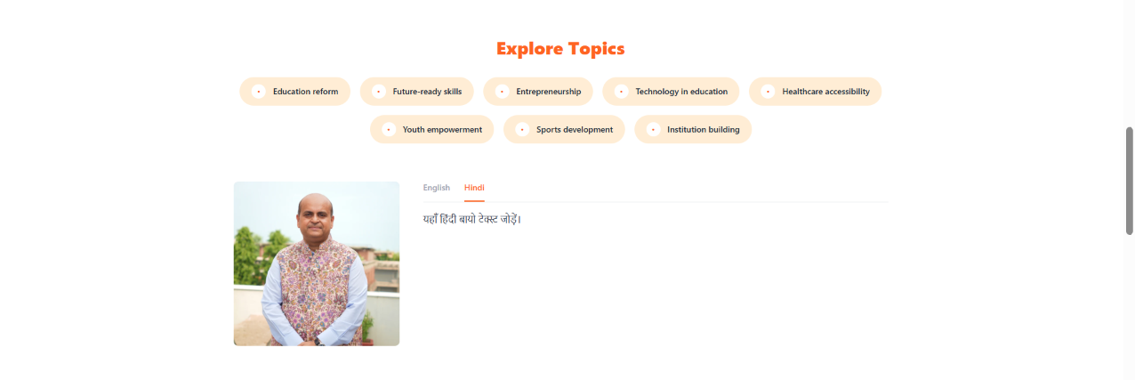

शैलेंद्र भदौरिया एक प्रतिष्ठित शिक्षाविद्, समाजसेवी एवं संस्थान निर्माता हैं, जिन्हें शिक्षा, स्वास्थ्य और खेल के क्षेत्र में लगभग तीन दशकों का व्यापक अनुभव प्राप्त है। वे वर्ष 1996 में स्थापित महाराणा प्रताप ग्रुप ऑफ इंस्टीट्यूशंस के संस्थापक सदस्यों में से एक हैं। वर्ष 2011 में उन्होंने जयपुर में प्रताप विश्वविद्यालय की स्थापना की।
उनके नेतृत्व और दूरदर्शी सोच से लगभग एक दर्जन शैक्षणिक संस्थानों, 600 बिस्तरों वाले अस्पताल तथा देहरादून वॉरियर्स टीम की स्वामित्व वाली चेतक स्पोर्ट्स प्राइवेट लिमिटेड जैसी पहलों को नई दिशा मिली है।
शिक्षा के विस्तार, युवा सशक्तिकरण और सामाजिक विकास में उनके उल्लेखनीय योगदान के लिए उन्हें युवा उद्यमी पुरस्कार, जागरण रत्न और युवा शिक्षाविद् पुरस्कार सहित विभिन्न सम्मानों से सम्मानित किया गया है।

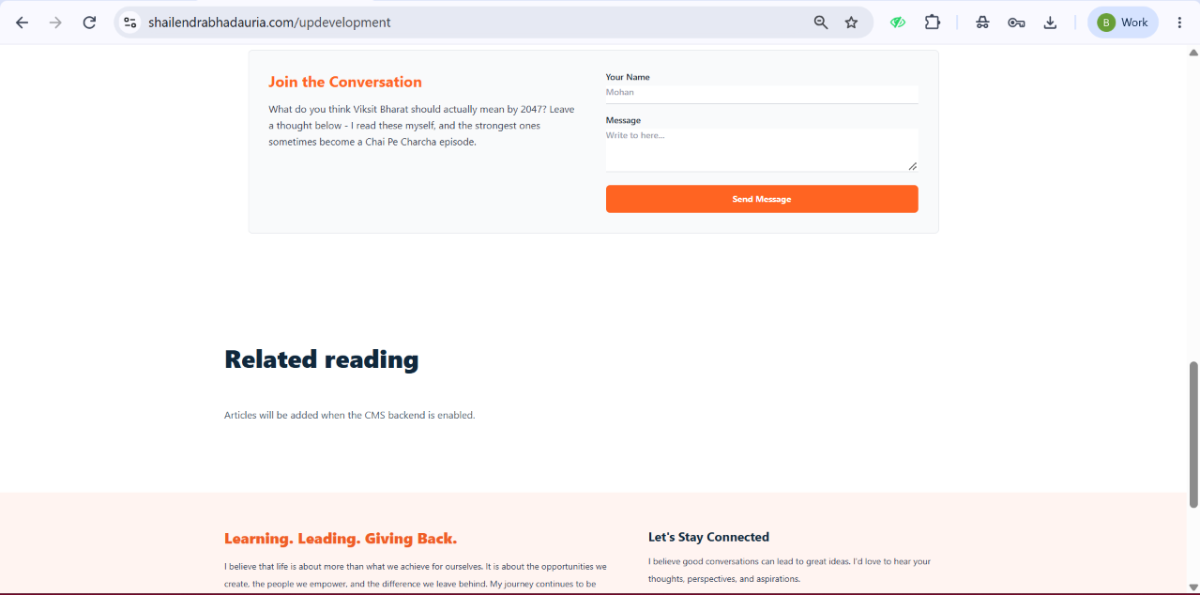

Same sequence issue + content not updated missing blog section

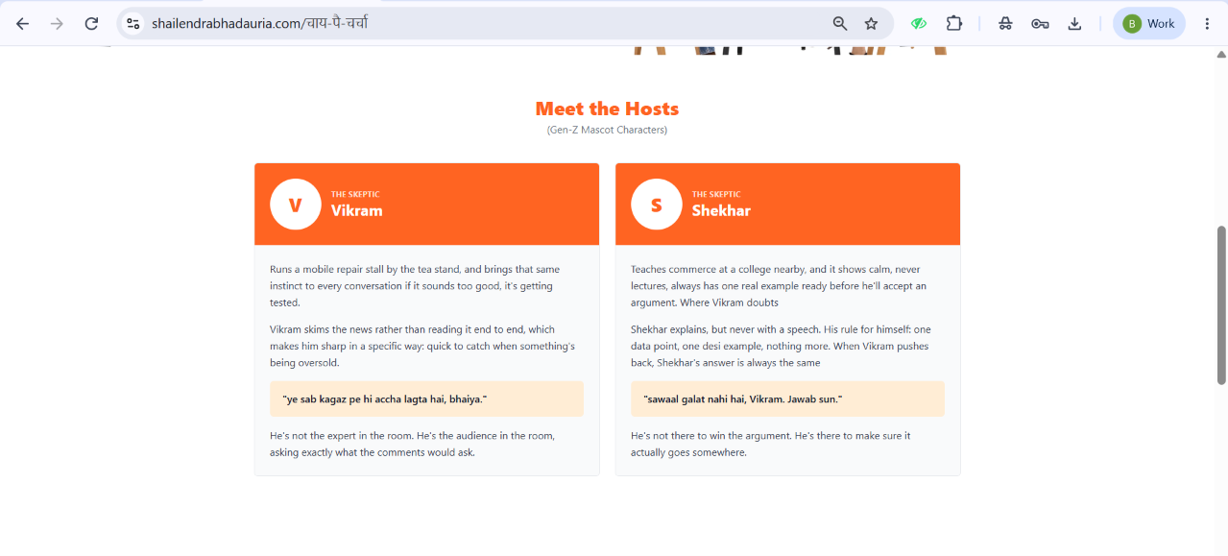

Hide this section

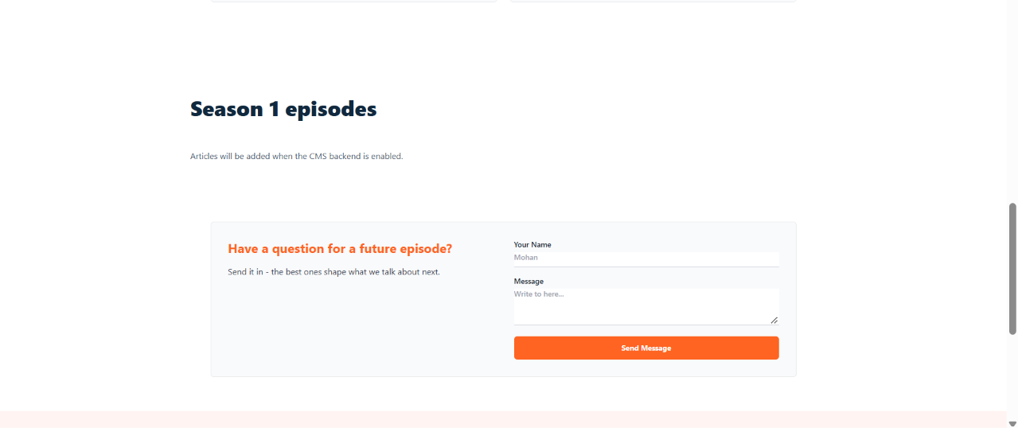

Heading will be Coffee Pe Charcha and as discussed we are doing a series on youtube those video will come here

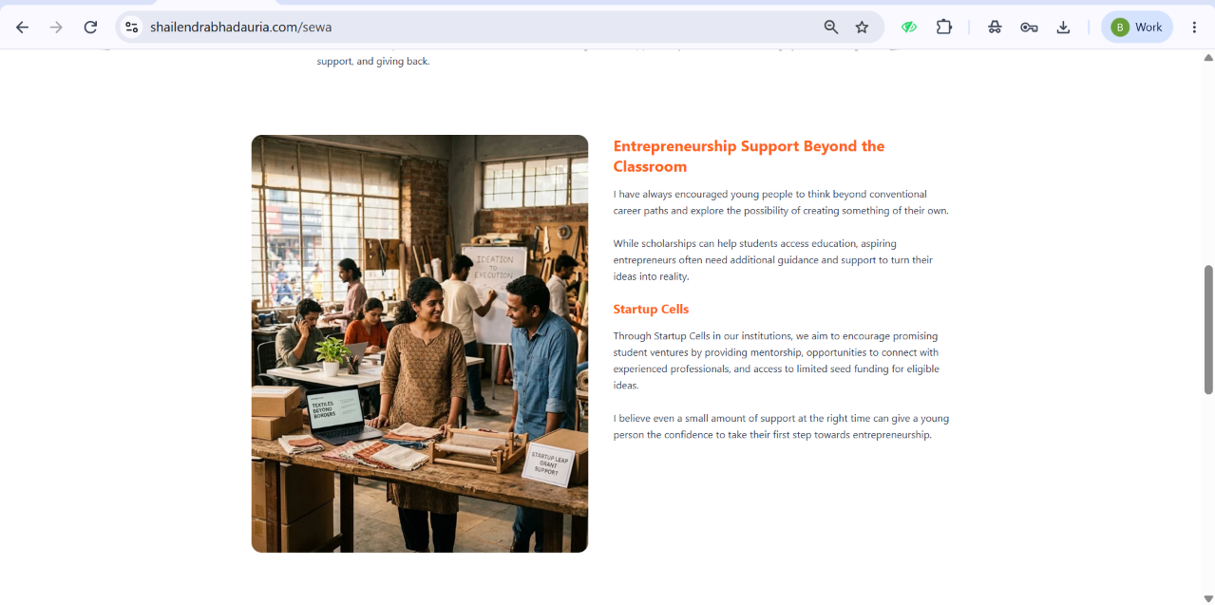

Check the image issue and layout need to be proper as discussed

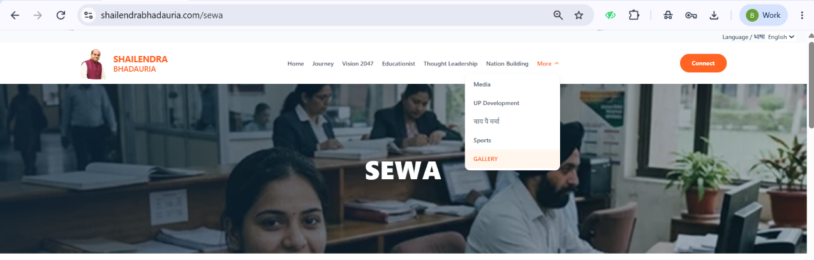

Drop down

Media Centre
UP Development
Coffee Pe Charcha
Sports
Sewa



